At start system is at rest and x₁ and x₂ are at their local zeros
M=mass=5.6699kg
k=spring damper=2709.57 N/m
b = Damper= 1.23948 Ns/m

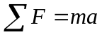
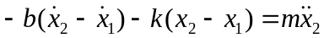
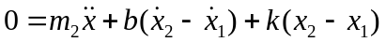
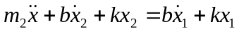

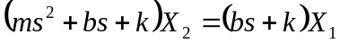

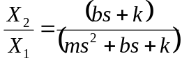 Transfer Function

Step Input 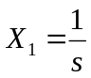

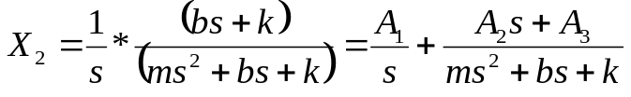

Using s=0, s=1 and s=2

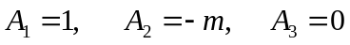

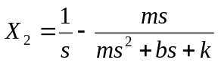

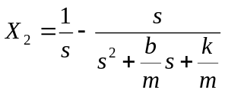
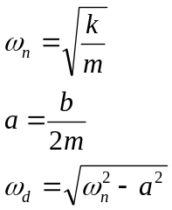

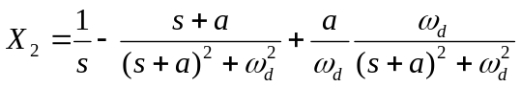
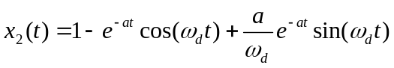

Step Input 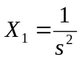

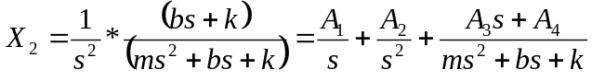

Using s=0, and looking at the s³, s² and s¹ terms:

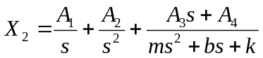

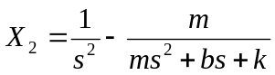
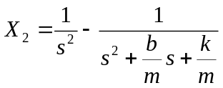
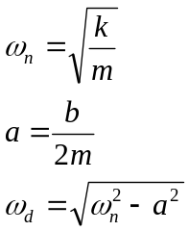

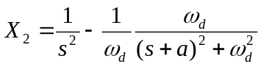
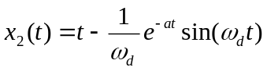

Mathematical Describe Complex Input

Ground

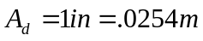
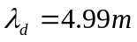

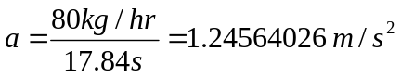

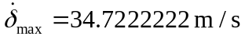

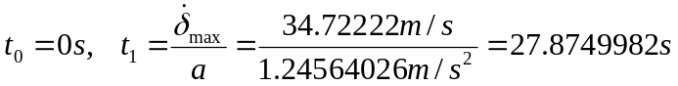

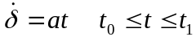
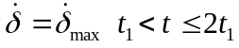

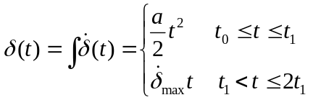

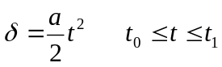
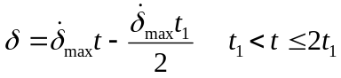

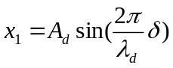

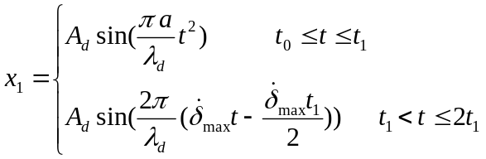

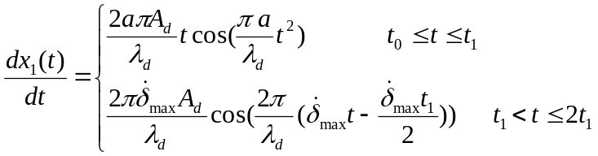

New Isolator

At start system is at rest and x₁ and x₂ are at their local zeros
M=mass=5.6699kg

Solve for New k:

Used straight line approximation
k=spring damper=175,126.835 N/m = 175.126 kN/m

Solve for New b:
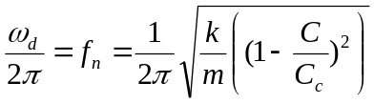
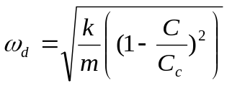
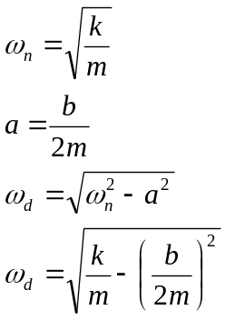
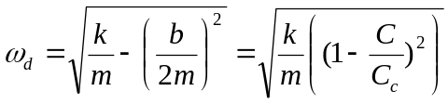
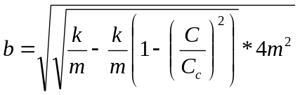

b = Damper= 24.45162 Ns/m

